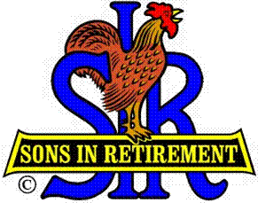

Las Trampas Branch 116

Luncheon Meeting Agenda

October 16, 2017

11:30 AM
- Call to Order – Big Sir.
- Welcome
- Pledge of Allegiance.
- Invocation: Matt Arena
- Introduce Head Table
- Little Sir: Marty Katz
- Guest Speaker – Fumble Fingers the Magnificent
- Introduce Guests & Visitors
- Guests: Dan Del Bonta
- Visitors:
- Introduce New Members (if any)
- Big Sir Comment
- 2018 Officer Nominations – Membership vote.
- North Bay Fires
- Storyteller – Bob Testa

11:45 PM – Lunch
- Raffle Drawing
- Sunshine Report – Matt Arena

12:15 PM
- Committee Reports

12:30 PM
Little Sir:
- Introduce Guest Speaker – Fumble Fingers the Magnificent.
- Ask October Birthday guys to stand / sing Happy Birthday (Paul King & Robbie)
- Sign God Bless America.

